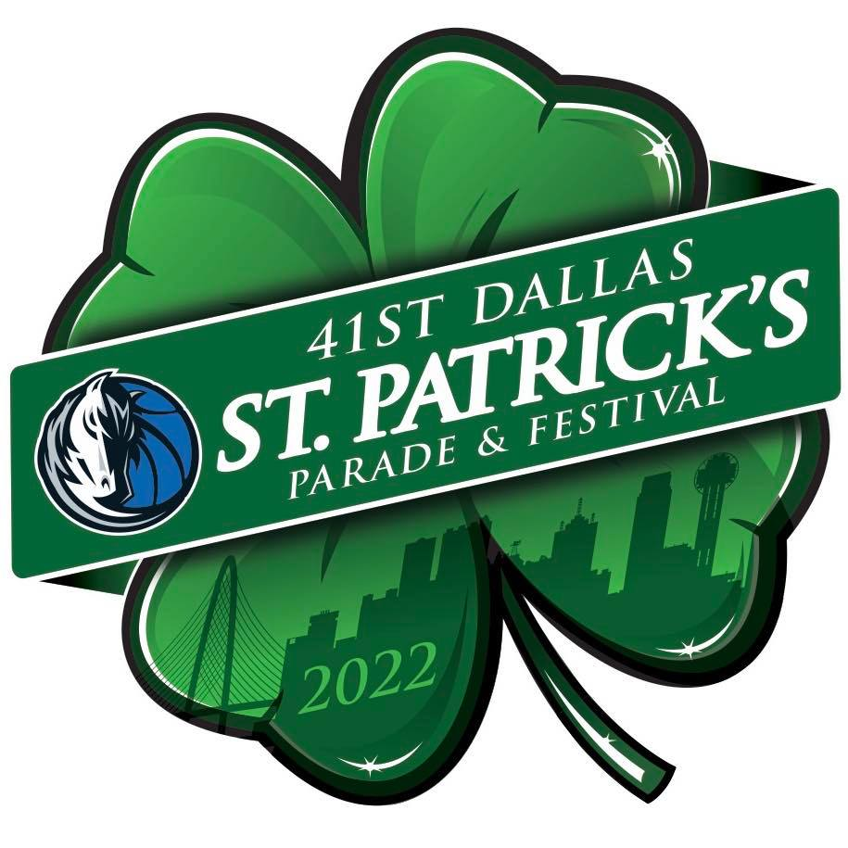

FOR IMMEDIATE RELEASE

Media Contact
Chris Kelley
214-457-5266
chris@MPDventures.com

Greenville Avenue Area Business Association Officially Announces
The 41st Annual Dallas St. Patrick’s Parade & Festival
on Saturday, March 12, 2022,
featuring Grand Marshal Dirk Nowitzki!

The largest St. Patrick’s parade in the Southwest has returned after a two-year hiatus, continuing one of Dallas’ best traditions, with proceeds benefitting the GAABA Scholarship Fund for graduating Dallas ISD high school seniors

(DALLAS – February15, 2022) – The Greenville Avenue Area Business Association (GAABA) is proud to announce the return of the 41st Dallas St. Patrick’s Parade & Festival on Saturday, March 12, 2022, presented by the Dallas Mavericks – the parade’s top sponsor since 2016. The parade will begin at 11 am on Greenville Avenue at Blackwell Street and end at SMU Boulevard and Central Expressway. The festival will run from 9 am until 3 pm, with a concert at Energy Square until 5 pm.

Attended by over 125,000 people each year, the largest St. Patrick’s event in the Southwest will return after a two-year pandemic hiatus, featuring Mavs living legend Dirk Nowitzki as this year’s Grand Marshal. Nowitzki retired from the Dallas Mavericks in 2019 as an MVP and NBA champion after 21 seasons. His number, 41, was retired by the Mavericks earlier this year.

“Every year we look forward to one of the biggest events in Dallas, the St. Patrick’s Parade, and this year we are thrilled to once again partner with the Mavericks and Dallas’ own Dirk Nowitzki to bring that vision to life,” said Kevin Vela, Board Chairman of GAABA. “The Mavs organization has been our number one sponsor for many years and a phenomenal parade partner. We’re proud to work together to bring top notch family-friendly entertainment to the community while making a valuable contribution to area youth through our educational scholarship fund.”

Featured Events
The parade has delighted families and children for more than 40 years and has attracted some of the best entertainment in the Metroplex. Featured event activities are open from 9 am to 3 pm, with the concert going to 5pm. Noted events include:

- CW33 (KDAF) Parade Live Broadcast will run from 11 am -1 pm at 5252 Greenville Ave.
- The Festival Zone will be situated at 5111 Greenville Ave. (Office Depot/CVS) and will feature food trucks, exhibitor booths, sponsor exhibits, family friendly activities, and a VIP Tailgate Area.
- The 4th annual Comerica Bank Family Zone is located at Lovers Lane and Greenville Avenue and will be equipped with bleacher seating and events for the entire family.
- The Dallas St. Patrick’s Parade Official Concert area, located at Energy Square, will feature a VIP parade viewing deck, concessions, food trucks, and DJs (over 21 only).
- A new attraction this year is the official concert, produced by Jaxon Beer Garden, at Energy Square, and featuring the headline act Toadies from 3:30 – 5 pm.

“The Mavericks are excited to be partnering once again with GAABA in 2022 to showcase one of Dallas’ most beloved traditions,” said Cynt Marshall, Dallas Mavericks CEO. “We love bringing the community together, and as a presenting sponsor, the Dallas Mavericks are showing up big with the Mavs Express bus, Mascots, and ManiAACs.”

Scholarship Goals
Proceeds from this year’s parade will go toward the GAABA Scholarship Fund, which provides a total of $45,000 dollars to graduating seniors in DISD. Each year, GAABA awards $15,000 to select students at Conrad, Wilson, and North Dallas High Schools.

Online donations may be made at https://dallasmavsstpatricksparade.eventbrite.com. Click: “select a time” and then “tickets.” Scroll to the bottom for the Donations box and enter your desired amount.

“Our goal this year is to raise $41,000 in donations, which aligns with celebrating the parade’s 41st year and in honor of #41 -- our Grand Marshal Dirk Nowitzki,” noted Vela.

Event Sponsors
- Presenting Sponsor: the Dallas Mavericks.
- Official Parade Sponsors: 7-11, Comerica Bank, Visit Dallas Tourism Public Improvement District, DART, DoubleTree by Hilton Dallas-Campbell Centre, Emergency Ice, University Crossing PID, Versa Printing Inc., and Rental Shop.
- Media Sponsors: CW33, iHeart Radio, Lonestar 92.5, 97.1 The Eagle, Star 102.1, 102.9 NOW, and 106.1 KISS FM.
- Festival Sponsors: Buyers Barricades; Westwood Financial; Meadows Building at Energy Square; and US Energy Square LLC.

Timing & Transit Tips
The parade will begin at 11am, but the public is invited to arrive on Greenville Avenue for festivities beginning at 9am. Because of the crowds and popularity of the parade, visitors should plan to arrive early and leave late. The festival runs from 9am until 3pm, with the concert continuing until 5pm.

The parade route starts on Greenville Avenue at Blackwell Street—with street closures scheduled to start at 10:30 am for north and southbound lanes of Greenville Ave—and ends at SMU Boulevard at Central Expressway. Alternative routes around the parade area include Loop 12, Mockingbird Lane, and Park Lane with access to Skillman. Parade-goers are encouraged to ride share or ride the DART Rail, as parking is extremely limited. Recommended DART Rail stations include Mockingbird Station, Lovers Lane Station, and Park Lane Station.

About GAABA & the Dallas St. Patrick’s Parade & Festival
The Greenville Avenue Area Business Association (GAABA) was formed in 1987 to help unify area business and promote the Greenville Avenue region. Its first objective is and always will be the presentation of the annual Dallas St. Patrick’s Parade & Festival. The Parade has grown to be one of the largest St. Patrick's Parades in the country, with over 125,000 attendees and more than 100 parade entries. Proceeds benefit the GAABA Scholarship Funds benefiting Dallas ISD Seniors. More than $150,000 in scholarships have been awarded. Learn more at www.dallasstpp.com or on Facebook at The Official: Dallas St. Patrick’s Parade.

About the Dallas Mavericks
The Dallas Mavericks play in the Southwest Division of the Western Conference of the National Basketball Association (NBA) and began as an expansion franchise in 1980. The Mavs have won one NBA Championship (2011), four division titles (1987, 2007, 2010, 2021), and two conference championships (2006, 2011). The team is led by Owner Mark Cuban, General Manager Nico Harrison, and Head Coach Jason Kidd. In addition to on-court success, the Mavs are committed to making a difference in North Texas through outreach programs and the Dallas Mavericks Foundation. Learn more at www.mavs.com.

# # #

